**UIT2301 – PROGRAMMING AND DESIGN PATTERNS**

**PART B**

**Name:** B.Vasundhara

**Reg no:** 3122 21 5002 119

**Question:**

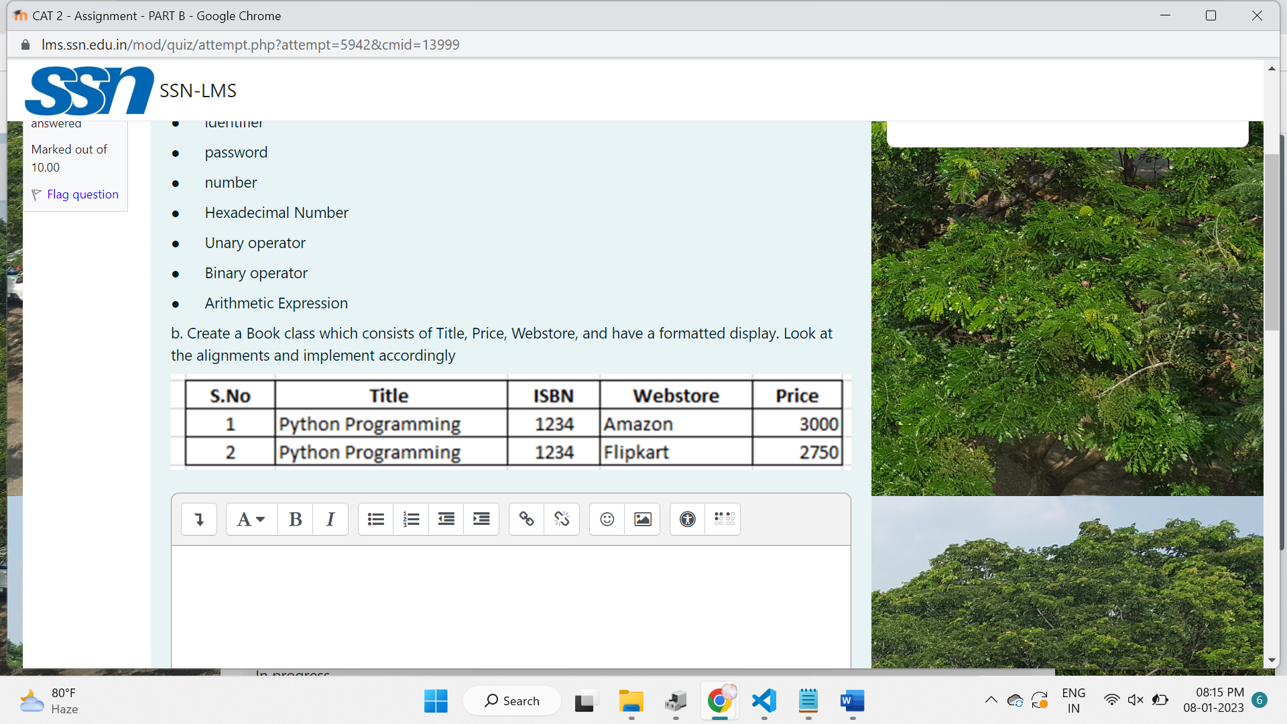

**Problem statement:**

To develop an application that contains the details of the book and display it in a formatted manner as shown in the question using string formatting.

**Why string formatting?**

Returns a Variant (String) containing an expression formatted according to instructions contained in a format expression.

 gap=" "*3

        heading=f"{'Sno':3s}{gap}{'Title':23s}{gap}{'ISBN':5s}{gap}{'Webstore':10s}{gap}{'Price':6s}"

        print('='*60)

        print(heading)

        print("-"*60)

        for book in self.books:

            rec=f"{book:3s}{gap}{self.books[book][0]:23s}{gap}{self.books[book][1]:5d}{gap}{self.books[book][2]:10s}{gap}{self.books[book][3]:6d}"

            print(rec)

**OUTPUT:**

1. **Adding new book**

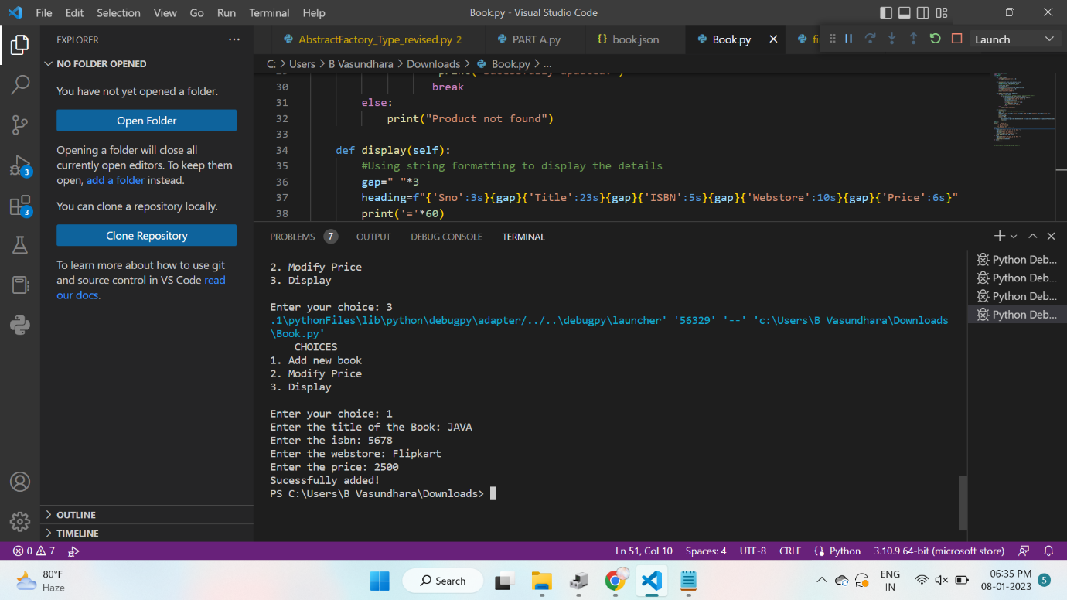

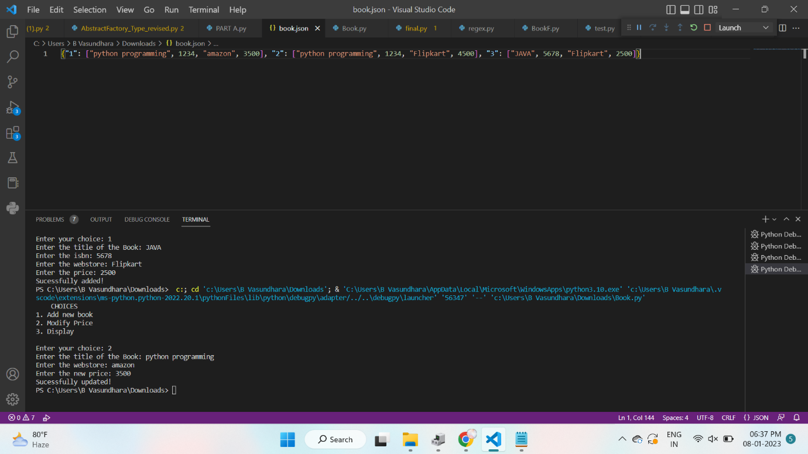

1. **Modifying price**

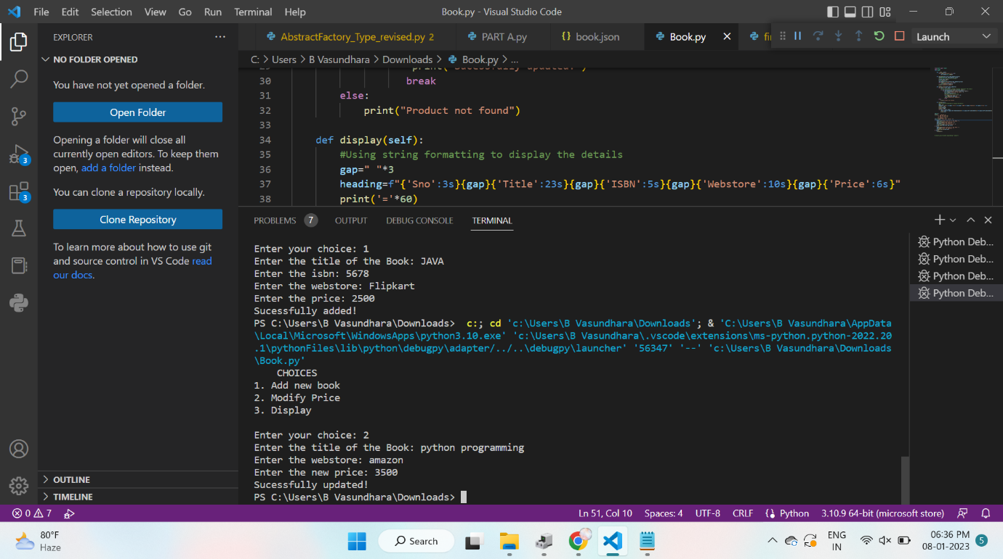

1. **Displaying the details**

